August 10, 2025

Mr. Ryan Harriman
Planning Manager
City of Mercer Island, Community Planning and Development
9611 SE 36th Street
Mercer Island, WA 98040

RE: Mercer Island Beach Club Response to Comments regarding Shoreline Substantial Development Permit

Dear Ryan,

On behalf of the Mercer Island Beach Club please see our responses to each of the comments consolidated from the documents sent to MIBC dated May 22, 2025.

If you should have any questions, please do not hesitate to contact me at your earliest convenience.

Sincerely,

Gardner Morelli
MIBC Board of Trustee and Committee Lead on Marina and Shoreline Renewal

Planning:
1. Please review and prepare responses to the public comment received from the WA
Department of Ecology dated May 20, 2025 (attached). Please see Ecology responses 4903-8910-2162.3
2. Please review and prepare responses to the public comment received from the
Snoqualmie Indian Tribe dated May 14, 2025 (attached). Please see attached document from Drayton Archelogy (Drayton Cultural Resources Review- MIBC 062525)
3. Please review and prepare a response to the third-party peer review completed by
Facet (attached). The inconsistences between JARPA, NNLR and Plan set have been addressed.
4. Please review and prepare responses to the public comments received on May 10,
2025 from Patricia Bostrom (below).

Statement and Question 1 from Patricia Bostrom:

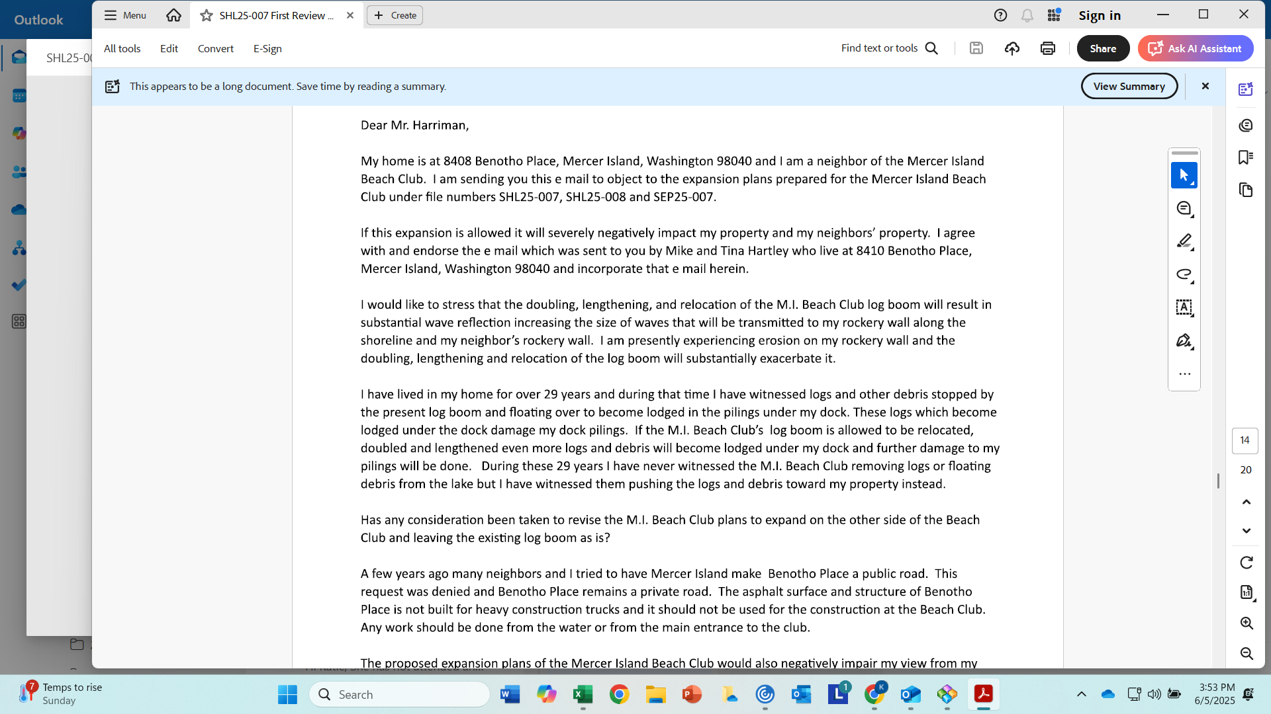
MIBC Response to Statement and Question 1 from Patricia Bostrom
- Loose log flow and debris from the Cedar River is a recurrent issue and varies year-to-year based on weather. This impacts all lakefront properties.
- Although we cannot attest to the past 29 years in its entirety, Mercer Island Beach Club’s operation plan does include monitoring the waterfront and removal of logs and debris. When the logs are too big, Mercer Island Marine Patrol is called and scheduled to remove.
- Mercer Island Beach Club does not operate with the intent or directive to “push” debris into neighboring properties.
- The General Manager has no record of contact by this neighbor/member regarding any complaints about debris.
- For boater and swimmer safety, the club actively removes logs & debris on an ongoing basis from the lake
- We interpret your question concerning the log boom in being double in width. The proposed design only includes a single width log boom.
- We interpret your question concerning the length from shore in doubling to its proposed furthest point in the lake, it is not double.

Question 2 from Patricia Bostrom:
MIBC Response to Question 2 from Patricia Bostrom
- The “Other Side” of the Club only includes “E” and “F” docks and a boat launch (remaining intact). There is no additional room to include a swimming area within the Club’s property lines.

Statement 3 from Patricia Bostrom:
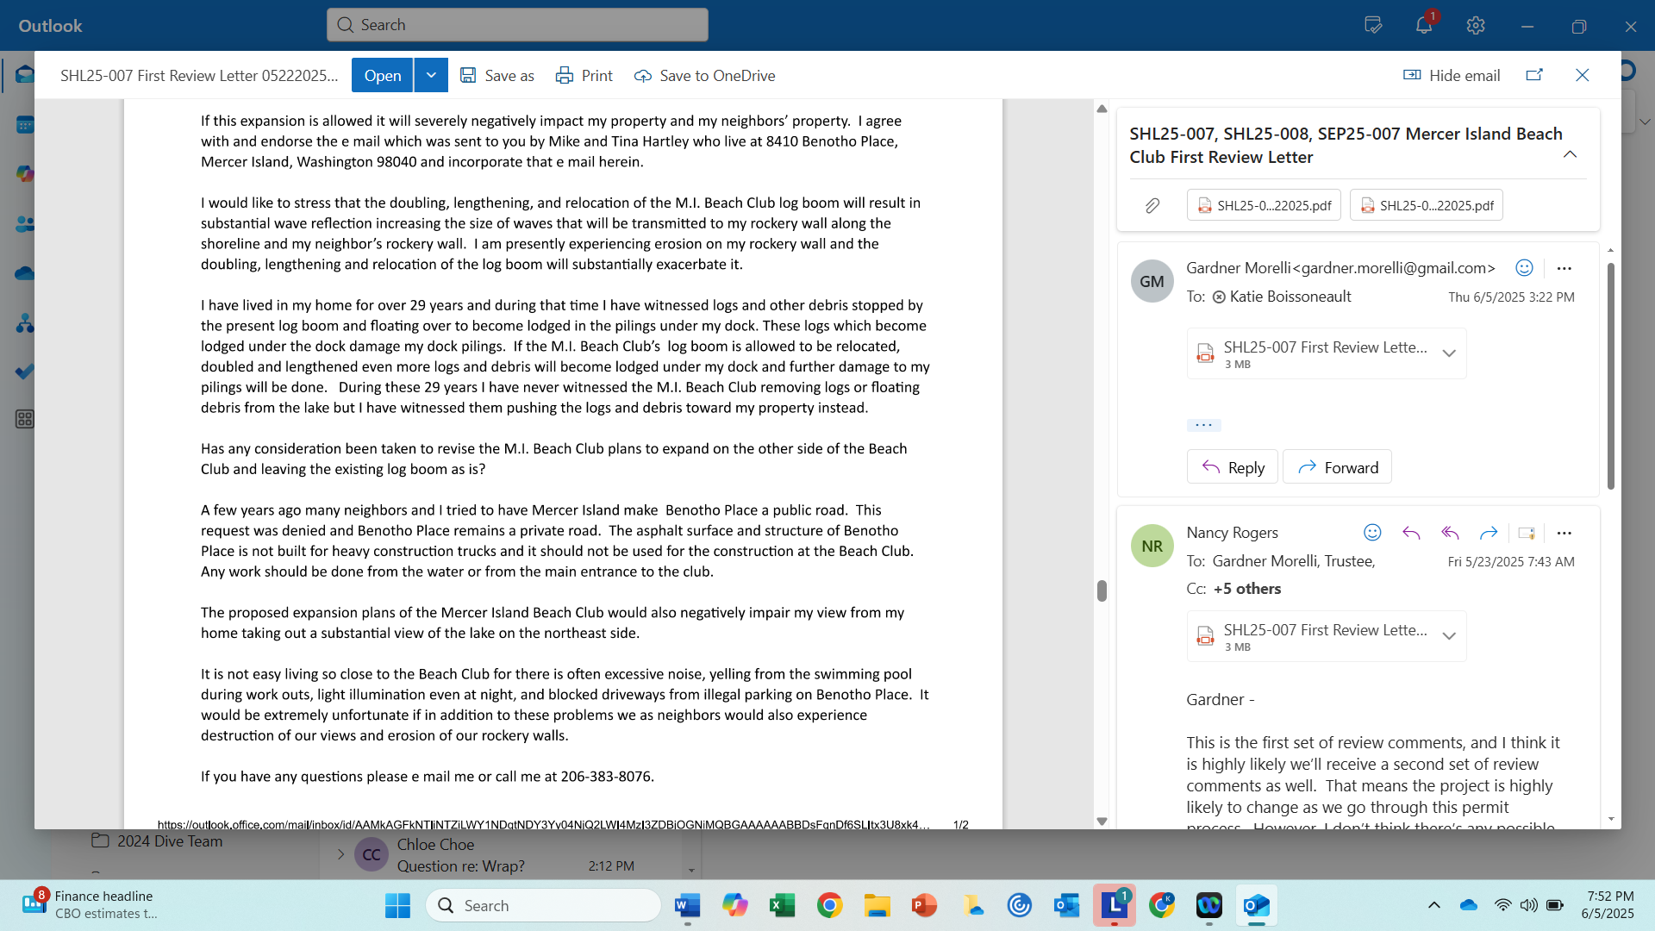
MIBC Response to Statement 3 from Patricia Bostrom
Mercer Island Beach Club intends to use the main entrance for vehicle access and lake for in-water deliveries.
Statement 4 from Patricia Bostrom:
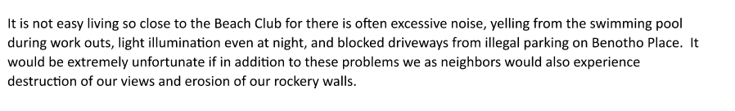
MIBC Response to Statement 4
- MIBC has been located at its current location generating great family memories for Island member residents and their quests in a safe and welcoming environment for over 70 years. The work that is being performed is updating the current marina to accommodate the same number of boats that are in use today while taking into account different code and ecological requirements of today. This will not increase any parking issues on Avalon Drive, 85th or Benotho Place. Regarding Benotho place, there is no authorized access to the Club but rather a side gate that is used by Members who live on Benotho or 85th which actually decreases traffic and congestion within the Club's parking lot. The marina work being performed is in the center of the Clubs property and within the inner harbor line. The SW side of our property line is impacted by an adjustment of a single log boom which floats on the water with the other adjustment being the placement of the swim dock which will, for swimmer safety, be placed a little further in the lake to ensure deep enough water for the swimmers within the designated swim area. None of the proposed work encroach on other property owners.
- When it comes to erosion of the shoreline, the Club has experienced this just like our neighbors. Storms continue to get more intense and the number of slow-moving wake surf boats continues to increase.

5. Please review and prepare responses to the public comments received on May 11,
2025 from Mike and Tina Hartley (below).
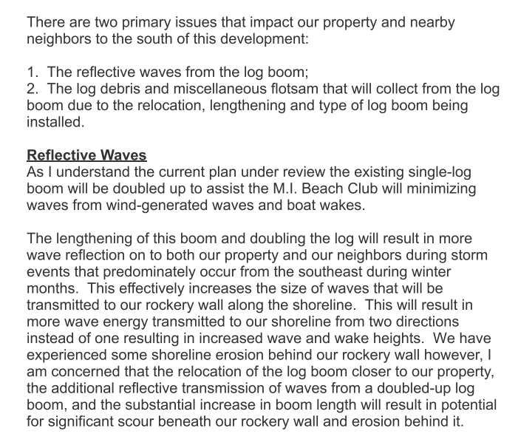
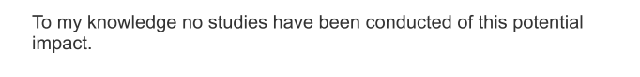
MIBC Response to Mike and Tina Hartly’s first primary issue and statement
- Please see the attached engineering report to request your concerns. (Mercer Island Beach Club- Wave Reflection_FINAL)
- We interpret your question expresses concern regarding the log boom being double in width. The proposed design only includes a single width log boom.
- We interpret your questions expresses concern regarding the length from shore to its proposed furthest point in the lake, it is not double.
Mike and Tina Hartly’s second primary issue:
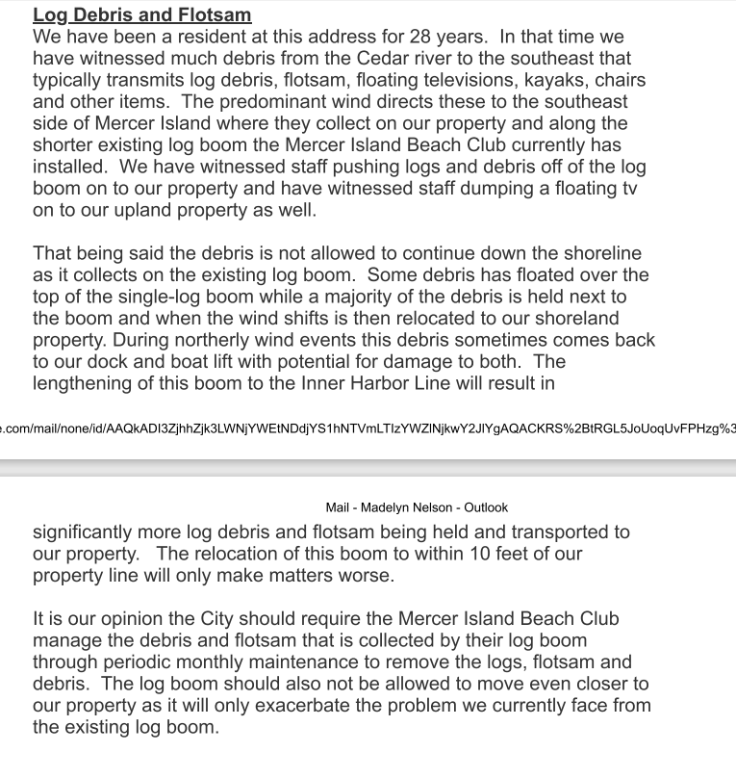
MIBC Response to Mike and Tina Hartly’s second primary issue
- Loose log flow and debris from the Cedar River is a recurrent issue and varies year-to-year based on weather. This impacts all lakefront properties.
- Although we cannot attest to the past 29 years in its entirety, Mercer Island Beach Club’s operation plan does include monitoring the waterfront and removal of logs and debris. When the logs are too big, Mercer Island Marine Patrol is called and scheduled to remove.
- Mercer Island Beach Club does not operate with the intent to “push” debris into neighboring properties.
- The General Manager has not been contacted in writing by this neighbor/member regarding any complaints about debris.
- Mercer Island Beach Club’s proposal contains development within the property line as recorded on the City records.
Additional Statements from Mike and Tina Hartly.
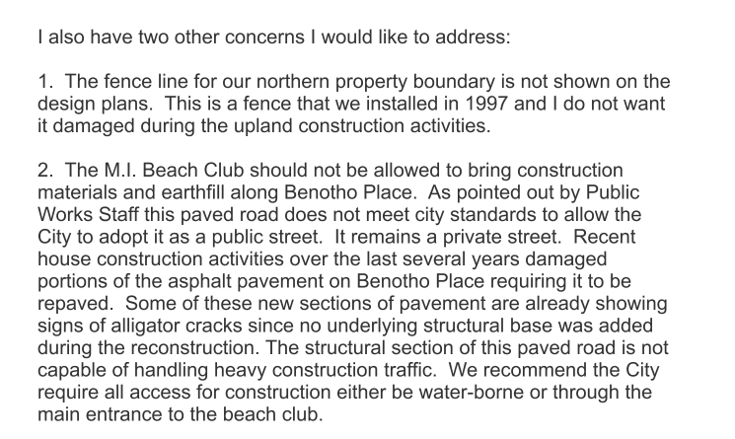
MIBC Response to Mike and Tina Hartly’s additional statements
- Mercer Island Beach Club’s proposal contains development within the property line as recorded on the City records. There are no plans to impact the fence.
- Mercer Island Beach Club intends to use the main entrance for vehicle access and lake for in-water deliveries.

6. Please review and prepare responses to the public comments received on May 6,
2025 from Mark and Marian Sinkey (below).
Statement 1
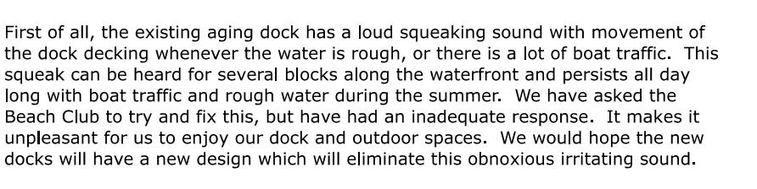

MIBC Response to Mark and Marian Sinkey’s statement 1
- There is no complaint on record from M. Sinkey with a request to fix
- MIBC contacted the design-installer (OEM) of E& F dock to help identify opportunities to help reduce noise that comes from these structures. Noise comes from the connection between the gangway and land and the rollers that surround the piles. MIBC replaced at the end of July the metal shackles with plastic bushed swing links as well as replaced the gangway guides and rollers at the base of the ramp to further reduce noise. Noise has been reduced to almost nothing since this change out and even during Seafair weekend, the noise was almost non-existent.
- Per the recommendation of the designer of the new marina- “the new gangways for the new marina will have plastic bushed swing links that will not make steel on steel noises. All piles will have roller guides to minimizes rubbing, squeak noises as well.”

Mark and Marian Sinkey’s statement 2

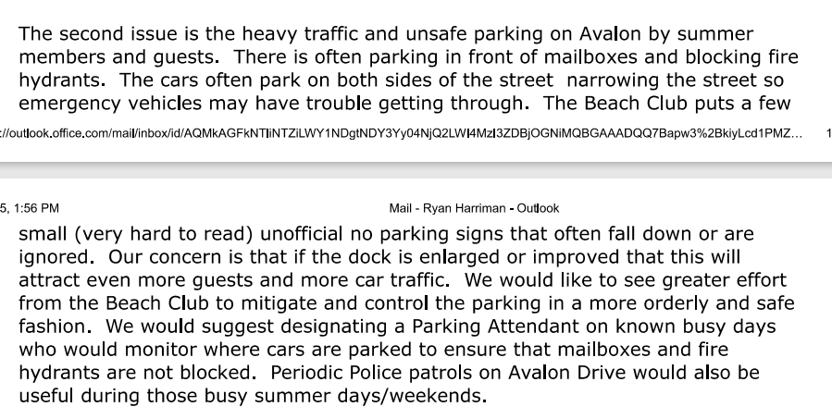
MIBC Response to Mark and Marian Sinkey’s statement 2
- Avalon Drive is a public road.
- The Mercer Island Beach Club takes the following actions every summer to assist in managing parking.
  - Installing “SLOW” and “No Parking” signs on Avalon Drive.
  - Contracting valet parking for all Home Swim Meets (5 in total) to accommodate as many cars possible in the parking lot.
  - Providing residents on Avalon Drive a schedule of summer events including 5 Home Swim Meets, July 4th Celebration & Adult Summer Party.
- In recent years, the number of large swim meets has declined due to changes in Midlakes end of season event schedule (no Senior Prelims events).
- The plan for the marina replaces existing boat slips on a 1:1 basis. No added traffic volume is anticipated and no change in membership numbers as a result of this project.

7. Provide a diagram showing the calculations of both existing and proposed lot
coverage and hardscape within the two shoreline areas (0-25’ and 25-50’ landward
from the OHWM).
MIBC Response: Please see sheet 26 or 27 of the Plan Set.
8. The applicant shall provide a navigation study to ensure the proposed marina does
not interfere with the public use and enjoyment of the water or create a hazard to
navigation.
MIBC Response- Please see Ecology responses 4903-8910-2163.3
9. Are there alternative designs that could avoid or reduce the marina’s expansion
farther into the lake?
MIBC Response- Please see Ecology responses 4903-8910-2163.3
10. Ecology is of the opinion that the additional overwater coverage from proposed
development would be a substantial adverse impact. Are there designs that could
avoid or further reduce this impact?
MIBC Response- Please see Ecology responses 4903-8910-2163.3
11. Ecology is of the opinion that the existing wave attenuator is a legal nonconforming
use, and the proposed design would “expand the existing wave
attenuator/breakwater and make it double as moorage”, which may require a
shoreline variance. Please provide an analysis of the design, size and configuration of
the overwater structure related to the demand analysis, navigation, wave attenuation
properties and other relevant factors.
MIBC Response- Please see Ecology responses 4903-8910-2163.3

12. Are there alternative designs that could eliminate floating platforms?
MIBC Response- Please see Ecology responses 4903-8910-2163.3
13. The applicant shall provide an analysis of the wake reflection as it relates to the
proposed log boom and possible impacts to adjacent properties. Has the project
designer considered possible negative impacts to adjacent properties caused by
wave reflection?
MIBC Response- Please see attached document titled “Mercer Island Beach Club- Wave Reflection_FINAL” which addresses wake reflection, and it impact to adjacent properties.
14. The applicant shall provide a plan to monitor and remove debris that may collect and
rest adjacent to the proposed log boom. The plan must ensure the debris is removed
and not simply relocated or pushed to a different location.
MIBC Response
- Loose log flow and debris from the Cedar River is a recurrent issue and varies year-to-year based on weather. This impacts all lakefront properties.
- The Facilities Director makes daily walks of the Mercer Island Beach Club’s property to assess and identify issues. When logs and debris are identified, the material is removed.
- If logs are too big to remove independently, Mercer Island Marine Patrol will be called and scheduled to remove.
- The Club has invested in a small john boat to assist in maintaining the beach club property clear of debris.
- Any concerns should be directed to generalmanager@mibeachclub.com and facilities@mibeachclub.com.

15. The applicant shall demonstrate the necessity of the concrete retaining wall . Could
the shoreline be softened using natural materials?
MIBC Response- The Club proposes to remove treated timbers that form the separation between the grass area where people lounge, picnic and traverse along the shoreline and the children’s protected sand play area along the lakefront. Removal of these treated timbers that break down over time, create splinters in children’s feet and hands, and become unsafe as they rot and cause issues with the grass area over time is part of our shoreline renewal plan. MIBC considered various solutions, and a small, compact concrete wall provided the most effective solution to allow for safe passage of people along the shoreline, allows for the families to continue to picnic and lounge and minimizes any risk of harm to children, and provides a long term solution for the club.
16. The applicant shall demonstrate the necessity of extending the swim dock over 100-
feet waterward from the OHWM.
MIBC Response- Please see Ecology responses 4903-8910-2163.3
17. Ecology is of the opinion that the proposed development does not appear to achieve
no net loss of ecological functions, with the primary adverse impact being expansion
of overwater coverage. The applicant shall provide additional mitigation measures to
offset the impacts of the proposed development.
MIBC Response- Please see Ecology responses 4903-8910-2163.3

18. The proposed development shall be designed to eliminate excessive squeaking
generated from the movement of docks. The applicant shall include design
measures in the proposed development that will mitigate noise generated by the
movement of docks.
MIBC Response
The Club has included language in the proposed design to ensure that the hardware provided will mitigate noise generated by the movement of the docks.

19. The applicant shall provide a parking plan that addresses parking demand during
peak use. The applicant shall monitor off-site parking and require members or guests
to park vehicles within the established parking areas on the subject property.
MIBC Response
The proposed marina design does not increase the number of boat slips from today’s design. We do acknowledge that the number of PWC (jet skis) increases by 5. The summertime is and has always been the high demand season for MIBC.. Many of the neighbors of MIBC are members too and we are sensitive in helping mitigate any traffic on Avalon, 85th, and EWM.
Parking Plan:
- The MIBC Parking Lot is maximized with 85 parking spaces + 6 handicapped parking spaces + 3 trailer parking spaces.
- Valet parking is contracted for all Home Swim Meets (5 in total) to accommodate up to 40 additional vehicles in the parking lot. During these events, the trailer spots are designated for vehicles (double parked) bringing the total to 137 parking spaces.
Monitoring of off-site parking:
The Mercer Island Beach Club takes the following actions every summer to assist in managing parking.
  - Installing “SLOW” signs on Avalon Drive.
  - Installing “No Parking” signs on lake side of Avalon Drive to ensure access for emergency vehicles while also providing improved safety and reduced inconvenience for residents.
  - Managing parking within the club property with a parking lot attendant.
  - Encouraging visitors and members to carpool to events.
  - Limits the number of events that may create adverse parking conditions.
Outside of the Club property, on a public street (Avalon Drive), it is an unreasonable directive to require Club staff to monitor public parking. Club staff are not in a position to identify if a vehicle is occupied by a guest of the Club or residents of Avalon Drive and, re-direct parking and furthermore have no authority to instruct members of the public on public property.

20. An archeological review shall be completed for the proposed development, as this is
an area the Snoqualmie Tribe considered culturally significant and has a high
probability of having unknown archeological deposits. If any archaeological work is
performed, the Snoqualmie Tribe request notification. An Inadvertent Discovery Plan
(IDP) should not be used in lieu of archeological investigation. Cultural and
archaeological resources are non-renewable and are best discovered prior to ground
disturbance.

MIBC response to 20
Please see attached document from Drayton Archelogy (Drayton Cultural Resources Review- MIBC 062525)

Building:
1. Comments related to construction codes are provided as courtesy for coordination
between the owner and any land entitlement agencies. Review of the project for
construction codes, including Washington State Building Code and Washington
State Existing Building Code, will be performed under a required Building Permit
Application. Applicable construction codes can be found in MICC 17.14.010 Section
MIBC Response: MIBC will be applying for a building permit.
101. The vesting of construction codes is address in MICC 17.14.101 Section 105.3.4.
2. This project will require a code analysis to be included in the building permit
construction documents that documents conformance with applicable non-
structural code. If this design relies or interacts with existing construction, there are
three available compliance paths available in the Washington State Existing
Building Code:
o Chapter 5: Prescriptive Compliance
o Chapter 6: Classification of Work
o Chapter 13: Performance compliance
MIBC Response: Four of the existing docks/piers are being fully replaced. The new docks/piers shall conform to the WSBV, this will be indicated on the building permit drawings.
3. In conventional building construction, Classification of Work is most commonly
applied.
MIBC Response: See Item No. 2 response.
4. This project creates or modifies an occupancy which is required to be categorized in
WSBC Section 302. Means of egress required by WSBC 107.2.3 needs to be included
in the construction documents for the appropriate occupancy. Where features are
required to be accessible, accessible means of egress must be provided per 1009.2
MIBC Response: The occupancy/use “U” swimming and boat piers shall be included on the building permit drawings.
5. Washington State Building Code 106.1 requires that construction documents be
prepared by a registered design professional where required in the
jurisdiction. RCW 18.08.410 provides exceptions to the requirement for a registered
architect, which do not clearly apply to this scope of work:
MIBC Response: An Architect licensed in the State of Washington shall prepare the necessary documents for building permit submittal.
6. Unless otherwise demonstrated, a registered architect appears to be required for
this project.
MIBC Response: An Architect licensed in the State of Washington shall prepare the necessary documents for building permit submittal.
7. Calculations and drawings herein are developed to demonstrate conformance with
structural aspects of Washington State Building Code, and calculations incorporate
and appropriate and more specific NAVFAC standard.
Nonstructural conformance with construction codes, including the Washington
State Building Code or possibly the Washington State Existing Building Code, will
also be required. In particular, accessibility of recreational boating facilities is
regulated by WSBC 1111.4.9. In general, recreational facilities including swimming
and bathing are covered under WSBC 1111.3. Although the accessibility requirements
of swimming and wading pools may not apply to this waterfront facility, they may
be helpful in demonstrating compliance with the general requirement.
MIBC Response: An Architect licensed in the State of Washington shall prepare the necessary documents for building permit submittal.

Engineering:
1. On Sheet 5 of 23, please clearly indicate the boundaries of the existing public sewer
easement for the lake sewer line, and confirm that no new piling structures are
proposed within this easement. MIBC Response: Confirmed
2. On Sheet 5 of 23, please show the existing side sewer connection from the main
sewer line, and confirm that there will be no conflicts between the existing side sewer
serving the existing building and the proposed new marinas. MIBC Response: Confirmed.
Fire:
1. On Sheet FP-01, please provide a note: "A Class I manual, dry standpipe shall be
provided in accordance with NFPA 303, NFPA 14, and COMI Standards.”
MIBC Response: Confirmed
2. On Sheet FP-01, lease provide a note: "One 4A 40BC portable fire extinguisher shall
be provided at each standpipe hose connection. Each portable extinguisher shall be
located in a listed weatherproof enclosure.”
MIBC Response: Confirmed

